After creating one circle, one square and one triangle and calling method makeVisible () and changing the color to red on circle1:

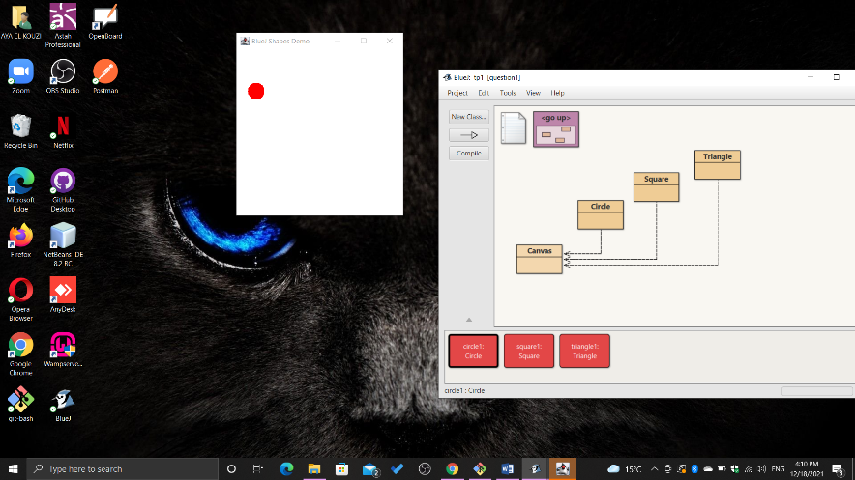

After calling the method changeSize(100):

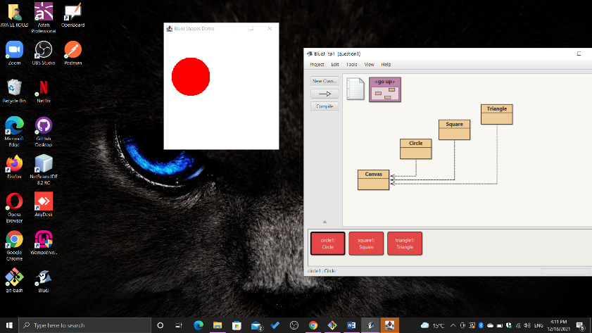

After calling the method moveDown() twice:

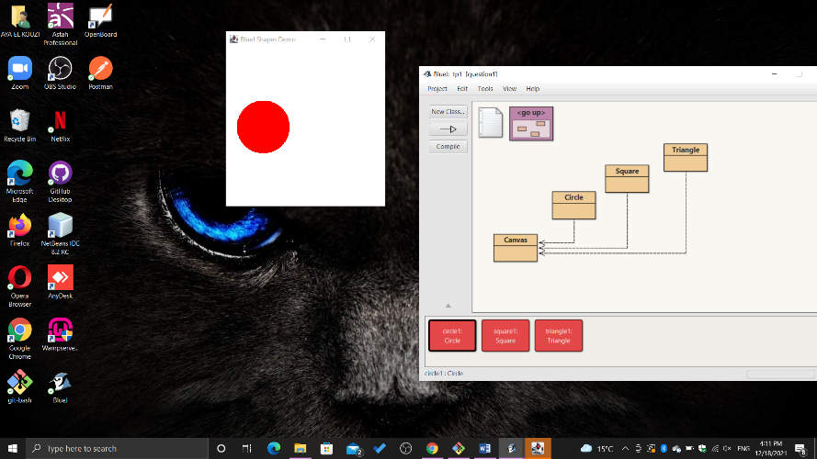

After calling the method moveHorizontal(200):

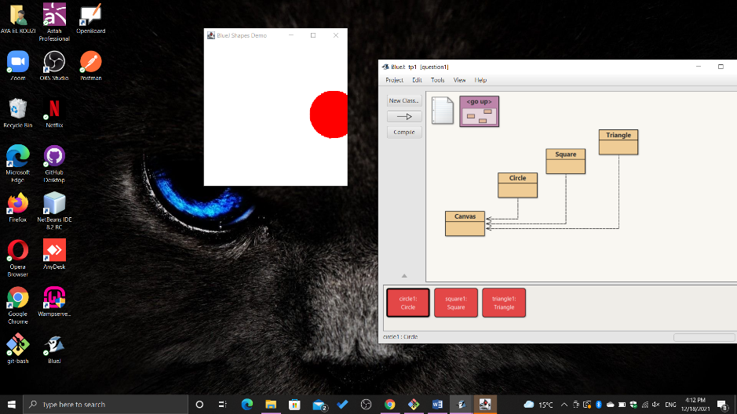

After calling the makeVisible(), changeColor(blue) and changeSize(40) method on square1:

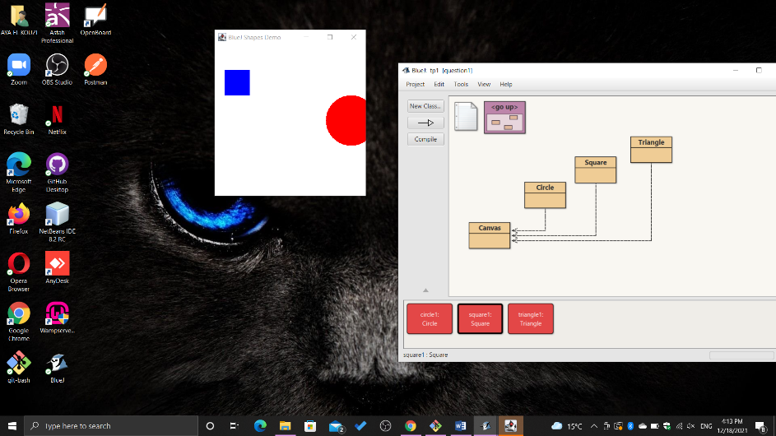

After calling the moveVertical(100) on square1:

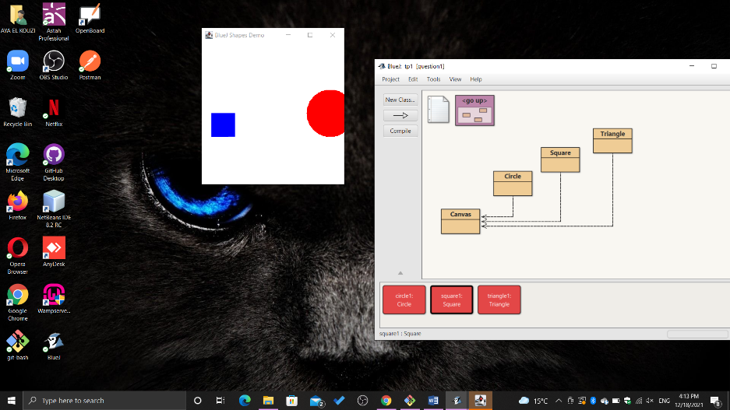

After calling makeVisible() method on triangle1:

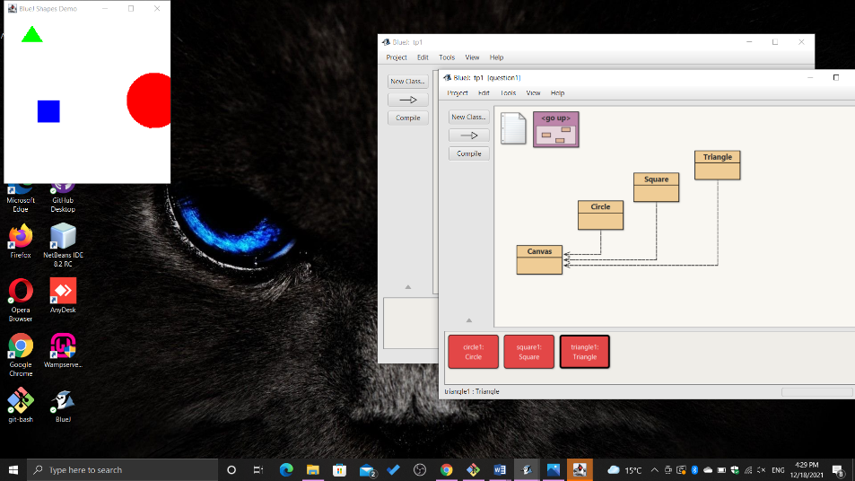

After calling the moveRight() method three times on triangle1:

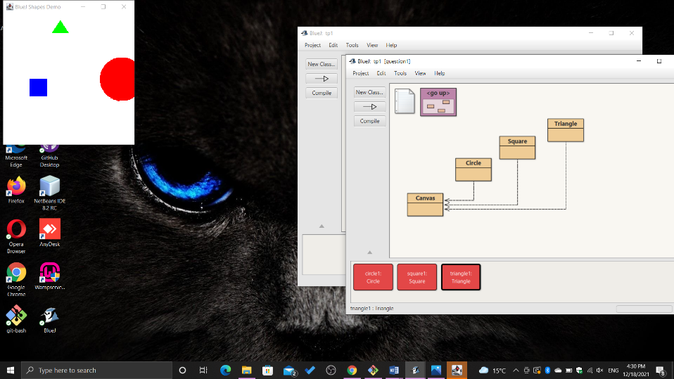

Before moving objects, we can see this picture of the object inspector for circle1, square1 and triangle1:

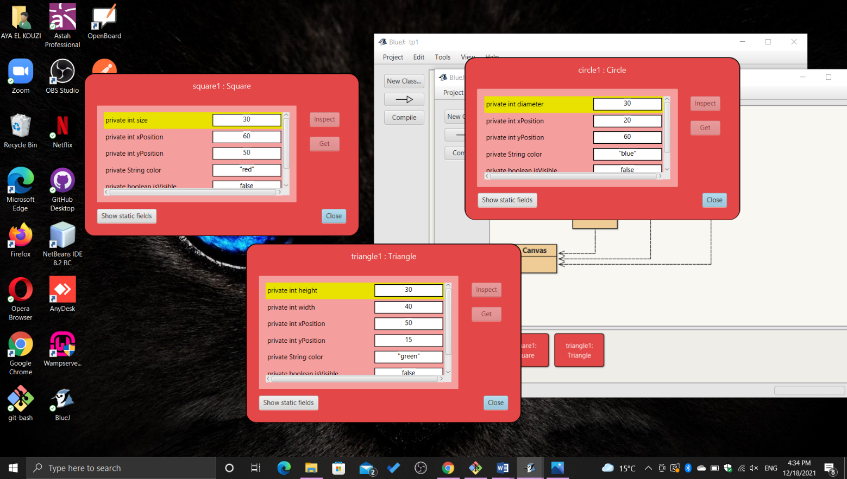

After calling moveVertical(40) on square1 for example and moveHorizontal(40), we can see that the variable yPosition and xPosition in square1 changes from 50px (in the first screenshot ) to 90px and from 60px to 100px in the second screenshot:

